National Cadets Judo Championships – 2024–25
22nd to 25th January 2025, PUNE
Final Entry Form - CADET BOYS

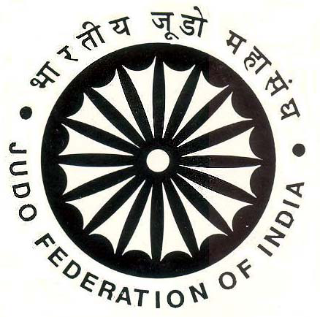
Name of State/UT :
Wt. Category | Name | Date of Birth | Father’s Name | JFI ID Number | Mobile Number
Below 50kg
Below 55kg
Below 60kg
Below 66kg
Below 73kg
Below 81kg
Below 90kg
Above 90kg
Coach
Manager
I, hereby, certify that the above players are free from Drugs & also true to their Age declared in this entry form. I also verified that AVT report submitting the above players are found correct. The above players can be verified/tested for the Drug & Age Verification, and if found positive, action can be taken against such erring players.
President/ Secretary
Signature & Stamp
Important Note: 1] The Entry Form MUST be TYPED Only 2] Original Entry Form MUST be submitted in DUPLICATE during Accreditation. PHOTOGRAPHS of all members must send with this form. Please send this Form before 2nd January 2025 to : jfiindia@gmail.com and Email: gs.mahajudo@gmail.com |  |  |  |  |  | Date:
National Cadets Judo Championships – 2024–25
22nd to 25th January 2025, PUNE
Final Entry Form for CADET GIRLS

Name of State/UT :
Wt. Category | Name | Date of Birth | Father’s Name | JFI ID Number | Mobile Number
Below 40kg
Below 44kg
Below 48kg
Below 52kg
Below 57kg
Below 63kg
Below 70Kg
Above 70Kg
Coach
I hereby, certify that the above players are free from Dope & also true to their Age declared in this entry form. I also verified AVT report submitting the above players are found correct. The above players can be verified/tested for the Anti-dope test & Age Verification, and if found positive, action can be taken against such erring players..
President/ Secretary
Signature & Stamp
Important Note: 1] The Entry Form MUST be TYPED Only. 2] Original Entry Form MUST be submitted in DUPLICATE during Accreditation. PHOTOGRAPHS of all members must send with this form. Please send this Form before 2ND January 2025 to : jfiindia@gmail.com and Email: gs.mahajudo@gmail.com |  |  |  |  |  | Date:

